Head pose tracking using multiple inertial sensors for virtual reality system

Yoon Suk Kwak, Soon Ki Jung

School of Computer Science and Engineering, Kyungpook National University
80 Daehak-ro, Buk-gu
Daegu, Republic of Korea
yoonsuk.kwak@vr.knu.ac.kr, skjung@knu.ac.kr

Abstract

This paper describes cumulative error of an inertial sensor and dominant sensor-based calibration method for head pose tracking and human pose estimation for virtual environments. Inertial sensor consists of gyroscope, and accelerometer, and it has been mainly used for navigation system, motion capture system, and so on. Inertial sensor has major disadvantage by cumulative error. Most systems use inertial sensor as a auxiliary sensor, with external reference sensor, or as interface for manual control on robot operating system using SLAM. Some inertial sensors have magnetometer to calibrate orientation, with respect to the magnetic north. However, magnetic filed is usually uncontrollable and unpredictable because of electric field by electric device, electric core, or steel frame construction. Especially, in virtual training system including head pose tracking and human pose estimation, human moves all around in a room or a building, magnetometer is not always suitable.
We present a novel method to calibrate orientation drift of position error of inertial sensor, We used a pair of sensors in order to minimize those cumulative error. One of them is mounted on foot. The other is mounted on head. We achieved fine accuracy and small error for human pose estimation for virtual reality environment with low-cost inertial sensor.

Keywords-component; human pose estimation; human motion analysis;virtual reality;inertial measurement unit;inertial sensor

I. Introduction

Recently virtual reality is widely used in the industry Virtual Reality(VR) is interactive computer simulations that sense the participant’s intention and replace or augment the feedback to one or more senses [Sherman and Craig]. Virtual reality can be alternative for doing immersive, dangerous, or expensive something in reality. VR trend is drived by development of hardward such as HMD(Head-Mounted Display) for sense of sight, treadmill for sense of kinesthetic, controllerless devices for interaction, and development of software by computer graphics, 3D sound technology, human motion technology, and so on. Among others, HMD devices and accurate head pose treacking is the most omportant because sight is dominant sense of human sense.
In virtual military training system, or virtual fire training system, these issues take a critical role for quality of training result. Recent HMD devices provide external sensors to compensate pose such as magnetometer or vision sensors. But, those training systems cover huge area and hang between indoor and outdoor. General positioning system such as GNSS(Global Navigation Satellite Systems), pre-installed or pre-configured system, is not accurate as much as sufficient. Alternative solution of head pose tracking is inertial sensors and vision sensor assisted by INS(inertial navigation system) with SLAM technology. However, vision sensor is not able to track momentarily, in a room filled with smoke or featureless structure. On the other hand, inertial sensor gathers continuous sensor data, but it has cumulative error by intergral calculus and it is not less accurate in long-term environment. For solving accurate pose tracking issue in INS, lots of compensation method have been developed for decades. Most popular approach is related with foot-mounted filtering. It is, regarded as similar research field, PDR(pedestrian deak recogkning).
In this paper, we present PDR based head pose tracking. We configure foot-mounted inertial sensor that has less error, and extract dominant human pose direction and movement, we compensated cumulative error of head sensor from pivot sensor.

II. Related work

Inertial Navigation System (INS) including Indoor Positioning System (IPS) [1] has developed rapidly with technological advances of MEMS [17]. Inertial sensor is inexpensive, small, and widespread, besides it has desirable and stable properties in most environment and wide coverage. In this field, tracking accuracy to eliminate integration drift is primary issue. Many researchers have tried to find solutions with lots of positioning techniques using GPS, Wi-Fi sensor networks, Ultra-wideband, Bluetooth, vision sensor, and inertial sensor [18,19,20,21]. However, most fusion systems require lots of expense for install and management. Pedestrian dead reckoning (PDR) [2.3,4], a part of INS, has several constraints related with motion characteristic of human for recovering from noise. It is more promising technique than others with external reference. PDR consists of heading, step detection [15], step length processes [16], which are performed by several types of sub-techniques such as stance detection [9], step cycle detection, step frequency, peak detection [10], zero crossings [11], auto-correlation or template matching [12], spectral analysis [13], pressure sensors. Most popular technique is foot-mounted Zero Velocity Updates (ZUPTs) [14] with sub-techniques [5,6,7,8]. PDR is still actively research field. There are major issues such as consistent evaluation methodologies and metrics, sensor calibration, and initialization [4]. Other alternative is simultaneous localization and mapping(SLAM) using vision sensor and dead reckoning using inertial sensor. Most research used IMU for assist sensor of visual SLAM. So, in localization, it was comfortable. But in human pose estimation, it is not comfortable because it was depend on one pose of single part.
Nowadays, MIMU(Multiple Inertial Measurement Unit) have issued by lots reason such as capabilities, uncertainty assessment, and accuracy [22]. MIMU is regard as single sensor or sensor arrays, which has enhanced accruracy of motion analysis.
In our paper, we focused on head pose tracking for virtual environments such as virtual military training system or fire training system.

III. Head pose compensation using foot-mounted sensor

Inertial sensor has several noise terms. These noises consist of internal noise that can be analysis by Allan variance and external noises such as temperature effects, sensor non-orthogonality, sensor fusion algorithm, magnetic distortion, G force and so on.
Foot-mounted inertial sensor has many way to compensate noise. Result of compensation drives foot-mounted sensor less cumulative error. And it is primary criterion for head pose compensation. Fig. 1 shows entire system flowchart. Fig. 2 shows the result of dominant acceleration and orientation, and step length estimation obtained from previous work [5].
INS has more difficult issue than PDR. Because INS has less constraints-compensation factor than PDR. Those relation is similar in terms of head pose and foot pose estimation. However, head has structural relation or constraints with foot or other body such as pelvis, and spine in human skeleton. So we tried to compensate head pose using relative position relation.
We set some constraints in head pose estimation. 1) Head pose is less accurate than foot pose. 2) Distance between head and foot is almost fixed by height of human. 3) Head position estimation has little change by comparison with real value due to static motion. 4) Relative direction between head and foot is almost fixed, and direction of head can be compensated by direction of foot. 5) human in static motion is set his body pose to initial pose.
Compensation process is separated by of two situation. In dynamic motion, if position difference is get out of initial height of human, head position is drived to relative position related with foot. Head pose is consistently compensated by double exponential smoothing. Input data is the average of relative head position and head position.
Head orientation estimation is more accurate than position estimation and it is acceptable. Because original purpose of IMU is orientation estimation. However, the direction of IMU has cumulative drift error, and it has to be compensated by external components that we use foot’s direction. So, in static motion, if head and foot has no motion, head direction can be compensated to initial orientation. And also, position is compensated regulary by dynamic motion.
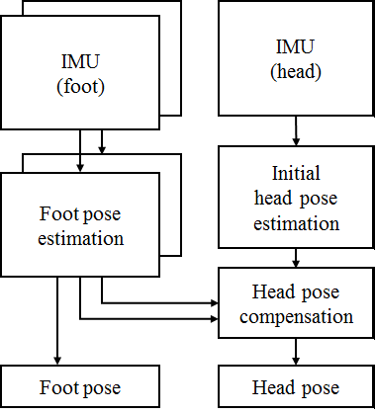
Fig 1. System flowchart

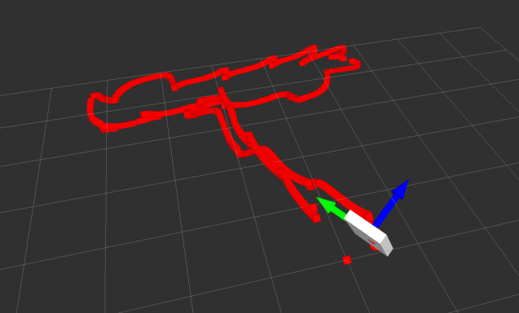
Fig 2. Foot pose estimation(previous work)

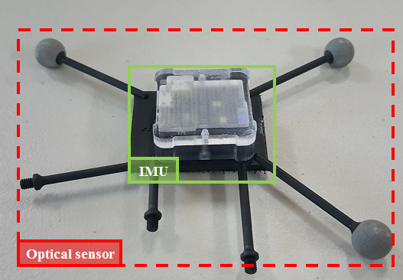
Fig 3. Sensor configuration

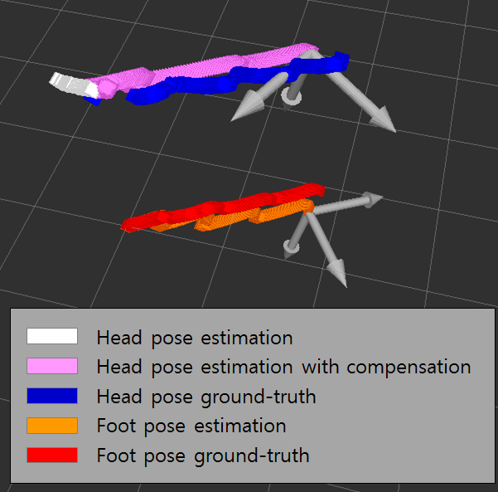
Head pose estimation
Head pose estimation with compensation
Foot pose estimation
Head pose ground-truth
Foot pose ground-truth
Fig 4. Head pose tracking result

Fig 3. Difference between ground-trouth(red) and experimental result(1 feet : blue, 2 foot : green)

Table 1. Experimental result
 | Dynamic and Static Compensation | Position Error  (m)
Foot pose estimation | N/A | 0.55
Head pose estimation | X | 2.32
Head pose estimation | O | 0.26
Fig. 3 shows system configuration and Fig. 4 shows compensation result of our work. Table 1 shows the result of head position compensation per 50 meter. Ground-truth is measured by optical sensor(NatrualPoint).

IV. Conclusion

We present a novel method to compensate orientation drift of position error of head-mounted inertial sensor exploiting foot-mounted sensor in order to minimize cumulative error. We achieved fine compensation of head pose. Accuracy of this method depends on performance of PDR. In future work, we will focus on human kinematics and collective fusion of multiple sensors. And we hope future work will be used for various virtual reality scenarios such as entertainment. And we will extend our research to human pose estimation for virtual military training system and fire training system for immersive reality environment.

Acknowledgment

This research is supported by Ministry of Culture, Sports and Tourism (MCST) and Korea Creative Content Agency (KOCCA) in the Culture Technology (CT) Research & Development Program (Immersive Game Contents CT Co-Research Center).

References

[1] Beauregard, Stephane, and Harald Haas. "Pedestrian dead reckoning: A basis for personal positioning." Proceedings of the 3rd Workshop on Positioning, Navigation and Communication. 2006.
[2] Jimenez, Antonio R., et al. "A comparison of pedestrian dead-reckoning algorithms using a low-cost MEMS IMU." Intelligent Signal Processing, 2009. WISP 2009. IEEE International Symposium on. IEEE, 2009.
[3] Fang, Lei, et al. "Design of a wireless assisted pedestrian dead reckoning system-the NavMote experience." IEEE transactions on Instrumentation and Measurement 54.6 (2005): 2342-2358.
[4] Harle, Robert. "A survey of indoor inertial positioning systems for pedestrians." IEEE Communications Surveys & Tutorials 15.3 (2013): 1281-1293.
[5] Rinara Woo, Yoon Suk Kwak, Eun-Ju Yang, Soon Ki Jung, Dae-Wha Seo, “Pedestrian Dead Reckoning Using Dominant Acclelation Tracking Algorithm (DATA).” IPIN 2015.
[6] Park, Sang Kyeong, and Young Soo Suh. "A zero velocity detection algorithm using inertial sensors for pedestrian navigation systems." Sensors 10.10 (2010): 9163-9178.
[7] Foxlin, Eric. "Pedestrian tracking with shoe-mounted inertial sensors." IEEE Computer graphics and applications 25.6 (2005): 38-46.

[8] Roetenberg, Daniel, Per J. Slycke, and Peter H. Veltink. "Ambulatory position and orientation tracking fusing magnetic and inertial sensing." IEEE Transactions on Biomedical Engineering 54.5 (2007): 883-890.
[9] A. R. Jimenez, F. Seco, C. Prieto, and J. Guevara, “A comparison of Pedestrian Dead-Reckoning algorithms using a low-cost MEMS IMU,” 2009 IEEE International Symposium on Intelligent Signal Processing, pp. 37–42, 2009.
[10] L. Fang, P. Antsaklis, L. Montestruque, M. McMickell, M. Lemmon, Y. Sun, H. Fang, I. Koutroulis, M. Haenggi, M. Xie, and X. Xie, “Design of a Wireless Assisted Pedestrian Dead Reckoning SystemThe NavMote Experience,” IEEE Trans. Instrum. Meas., vol. 54, no. 6, pp. 2342–2358, Dec. 2005
[11] P. Goyal, V. J. Ribeiro, H. Saran, and A. Kumar, “Strap-down Pedestrian Dead-Reckoning system,” in 2011 International Conference on Indoor Positioning and Indoor Navigation. IEEE, Sep. 2011, pp. 1–7.
[12] H. Ying, C. Silex, A. Schnitzer, S. Leonhardt, M. Schiek, S. Leonhardt, T. Falck, P. M¨ah ¨onen, and R. Magjarevic, 4th International Workshop on Wearable and Implantable Body Sensor Networks (BSN 2007), ser. IFMBE Proceedings, S. Leonhardt, T. Falck, and P. M¨ah ¨onen, Eds. Berlin, Heidelberg: Springer Berlin Heidelberg, 2007, vol. 13.
[13] T. Levi, R. and Judd, “Dead reckoning navigational system using accelerometer to measure foot impacts,” 1995.
[14] E. Foxlin, “Pedestrian Tracking with Shoe-Mounted Inertial Sensors,” IEEE Computer Graphics and Applications, vol. 25, no. 6, pp. 38–46, Nov. 2005
[15] M. Klepal and S. Beauregard, “A Backtracking Particle Filter for fusing building plans with PDR displacement estimates,” 2008 5th Workshop on Positioning Navigation and Communication, vol. 2008, pp. 207–212, 2008
[16] R. Harle, S. Taherian, M. Pias, G. Coulouris, A. Hopper, J. Cameron, J. Lasenby, G. Kuntze, I. Bezodis, G. Irwin, and D. Kerwin, “Towards real-time profiling of sprints using wearable pressure sensors,” Computer Communications, vol. 35, no. 6, pp. 650 – 660, 2012
[17] Titterton, David, and John L. Weston. Strapdown inertial navigation technology. Vol. 17. IET, 2004.
[18] J. Hightower and G. Borriello, “Location systems for ubiquitous computing,” Computer, vol. 34, no. 8, pp. 57–66, 2001.
[19] Taylor, James D., ed. Introduction to ultra-wideband radar systems. CRC press, 1994.
[20] Hol, Jeroen D. "Sensor fusion and calibration of inertial sensors, vision, ultra-wideband and GPS." (2011).
[21] De Angelis, Alessio, et al. "Indoor positioning by ultrawide band radio aided inertial navigation." Metrology and Measurement Systems 17.3 (2010): 447-460.
[22] Nilsson, John-Olof, and Isaac Skog. "Inertial sensor arrays? A literature review." Navigation Conference (ENC), 2016 European. IEEE, 2016.

